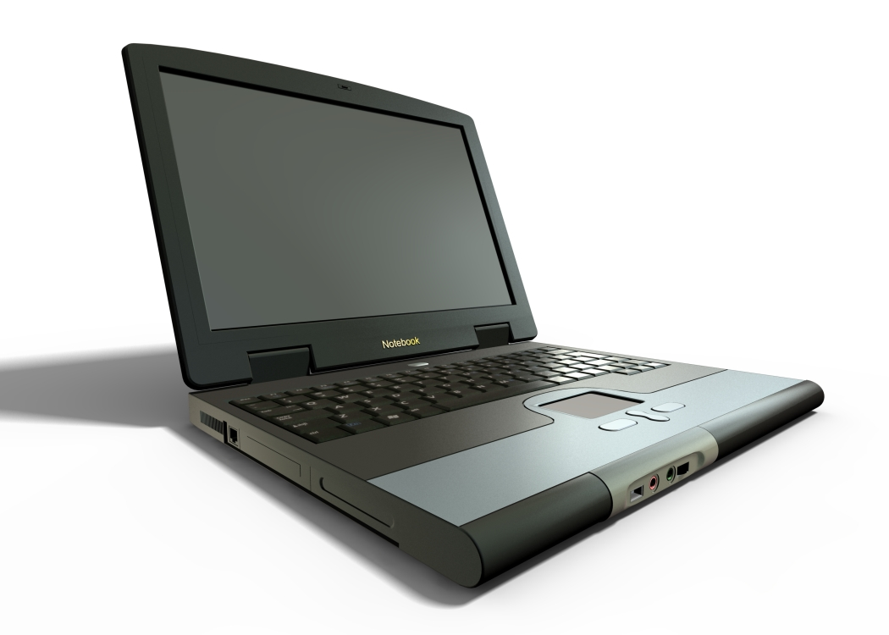
Leo J. Muir Elementary Electronic Devices Policy

Scope
Electronic devices have become a common means of communication and information access in today’s society. However, these devices have the potential of disrupting the orderly operation of the school. The school has therefore created this policy to govern the possession and use of electronic devices on school premises, during school hours, at school sponsored activities, and on school transportation.

Definition
For purposes of this policy “Electronic Device” means a privately owned wireless and/or portable electronic handheld piece of equipment that includes, but is not limited to, existing and emerging mobile communication systems and smart technologies (cell phones, smartphones, walkie-talkies, pagers, etc.), portable internet devices (mobile managers, mobile messengers, BlackBerry ™ handset, etc.), Personal Digital Assistants (PDAs) (Palm organizers, pocket PCs, etc.), handheld entertainment systems (video games, CD players, compact DVD players, MP3 players, iPods ©, Walkman ™ devices, etc.), and any other convergent communication technologies that do any number of the previously mentioned functions. Electronic Device also includes any current or emerging wireless handheld technologies or portable information technology systems that can be used for word processing, reading (NOOK, Kindle, or iPad etc.), wireless Internet access, image capture/recording, sound recording and information transmitting/receiving/storing, etc.

Possession and Use of Electronic Devices
Students may possess and use electronic devices at school subject to the following:
* Students may carry or possess electronic devices at school and school-sponsored activities.
* Use of electronic devices during the school day, including pass-time between classes and lunch-time, is prohibited. They must be completely powered down, turned off and kept out of sight (The best place for them during school hours is in each student’s backpack).
* Students may use electronic devices before 8:40 a.m. outside the school buildings and after the final bell of the school day outside of the school building, on school sidewalks, parking lots, and fields so long as they do not create a distraction or disruption.
* Use of electronic devices on school buses is at the discretion of the bus driver. Distracting behavior that creates an unsafe environment will not be tolerated.
* Use of electronic communication devices is not allowed on any other portion of the school campus at any time, including school-sponsored activities, unless an emergency situation as defined by school staff exists.

Internet Usage
Students do have wireless access availability. It is to be used only with the teacher’s permission and the purpose of teacher requests. Details can be found on the Technology Resources Acceptable Use Agreement. Internet usage is best activated on school devices instead of personally owned devices. Students must abide by the rules of the acceptable use agreement or face school or district disciplinary action.

Prohibitions
Electronic devices shall not be used in a way that threatens, humiliates, harasses, or intimidates school-related individuals, including students, employees, and visitors, or violates local, state, or federal law. Electronic devices may not be used during Utah Performance Assessment Systems for student assessments unless specifically allowed by law, student IEP, or assessment directions.

Confiscation
If a student violates this policy, his/her electronic device may be confiscated. When an employee confiscates an electronic device under this policy, he/she shall take reasonable measures to label and secure the device and turn the device over to a school administrator as soon as the employee’s duties permit. The electronic device will be released/returned to the student’s parent or guardian after the student has complied with any other disciplinary consequence that is imposed. Local policies may include:
* Potential disciplinary actions
* Security of devices
* Prohibitions on audio or video recording
* Procedures of reporting violations
* Exceptions
* Strategies for use of technology that enhance instruction

Potential Disciplinary Actions
* Violation of this policy can result in discipline up to and including suspension or expulsion, and notification of law enforcement authorities.
* A student who violates this policy may be prohibited from possession of an electronic device at school or school-related events.
* Confiscation of device for increasing periods of time for subsequent violations
* Failing citizenship grades.
* In-school suspension.
* Out-of-school suspension.
* Expulsion.
* Removal of privileges for extra-curricular activities
* Disciplinary consequences consistent with a school-wide discipline program such as demerit points.
* Loss of extracurricular or honor privileges or recognition.
* Notification of law enforcement, at school’s discretion, if circumstances warrant such notification

Security of devices
Students shall be personally and solely responsible for the security of electronic devices brought to school. The school shall not assume responsibility for theft, loss, damage, or unauthorized calls made from any location with an electronic device. If devices are loaned or borrowed and misused by non-owners, device owners are jointly responsible for the misuse of policy violation(s).

Reporting
Individuals wishing to report a violation of this policy should contact a school administrator.

Prohibitions on cameras and audio recording
Camera or audio recording functions of electronic devices may pose threats to the personal privacy of individuals, used to exploit personal information, and or compromise the integrity of educational programs. Accordingly, the use of audio recording or camera functions of electronic devices is strictly prohibited on school premises at all times.

Exceptions
With prior approval of the principal, the above prohibitions may be relaxed under the following circumstances:
* the use is specifically required to implement a student’s current and valid IEP;
* the use is at the direction of a teacher for educational purposes;
* the use is determined by the principal to be necessary for other special circumstances, health-related reasons, or emergency.

